Unit: Redshift and the Universe Expansion Name ________________________
Activity 2: The Expanding Universe Date _______________
Period ______________

Objectives: Students will…
- Illustrate the expansion of the Universe using a model.
- Explain the importance of Cepheid Variables.
- Use collected data to calculate Hubble Constant.
- Give supporting evidence for the Big Bang Theory

Background:
Edwin Hubble’s observations led to the realization that space itself is expanding, carrying all galaxies with it, and that all galaxies could have been closer together in the past. This leads to a concept of the origin of the Universe called the Big Bang Theory. When the Universe was once much smaller, the density (and temperature) of matter would have been very high. The theory says that the Universe began in an extremely hot and dense state and has been expanding ever since. The age of the Universe is estimated to be equal to the inverse of the Hubble Constant (1/H). The current estimate of the Hubble Constant (H) suggests that the Universe is about 13.7 billion years old.

Exploring the Hubble Graphics:
Study the graphic below and answer the following questions in the spaces provided

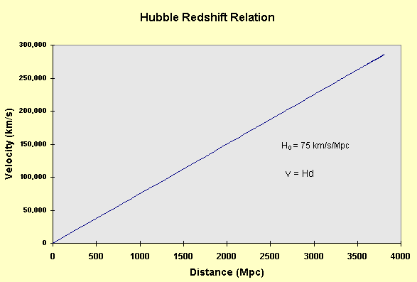
Q 1. What do the values on the horizontal axis represent?

Q 2. How might scientists measure this value?

Q 3. What do the values on the vertical axis represent?

Q 4. How might scientists measure this value?

Q 5. Which do you think is harder to measure?

Q 6. What type of relationship is shown by the graph?

Q 7. What are the units of the “slope?”
What could slope represent?

Q 8. What dimension do you get if you take the inverse of the slope?

Modeling the Expanding Universe:

Materials (Per group of 3) Slinky metric ruler
8 pieces string pencil or pen
calculator
Directions:
1. In this activity, you will create a model of the expanding Universe.
2. Tie 8 pieces of string to different parts of the Slinky. The Slinky represents the Universe, and the strings are galaxies that are moving as space expands.
3. Lay the Slinky on a flat surface and stretch it out a bit. Measure the distances between your home galaxy (the first string) and the remaining galaxies (other strings). Record your findings on the
data table below.
4. Carefully stretch the Slinky about twice as far and measure the new distance between your home galaxy and remaining strings. Record your findings on the table below. Calculate your change () in
distance for each.

String # | Distance from String 1  (Slightly stretched)  DI | Distance from String 1  (Stretched further)  D2 | D = D2 – D1

5. On the graph below, plot the values of D2 (the distances between the first string, home galaxy and the others) and D. You will need to choose the scales of the x-axis and y-axis.

D

D2 (Distance from String 1)
Q 9. Compare your graph to the front graph of the Hubble Redshift Relation. How are they similar and different?
(Note: Convert your value of D to a velocity like the first graph by dividing by 1 sec., assuming that the expansion you measured took place over 1 second).
Q 10. What does your graph of Hubble’s Law tell you about distance galaxies?

Q 11. What do you think you would see if instead of measuring the distance from the first string to the others, you measured from the second or third string?

Q. 12. Did your strings change in size as the Slinky expanded? Do you think a galaxy would change its size as the Universe expands? Why or why not?

Age of the Universe:
Astronomers use the Hubble Constant to estimate the age of the Universe. How is this done?
Imagine that instead of measuring strings on a Slinky, you arrived late to the starting line of a race that has already begun. Measuring the speeds of 5 cars (all of which are moving away) you find the following.

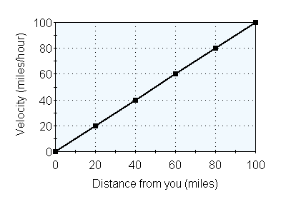
Q 13. What does this plot tell you about the cars?

Q 14. Did all of the cars leave the start line at the same time?
Q 15. If you assume that none of the cars has changed speed since the start, how long ago did they all leave?
Q 16. What is the ratio of the cars’ velocities to their distances (the slope of the plot shown above)?
What are the units?

Q 17. What is the ratio of the distances to the velocities (1/slope)? What are the units? How does this value compare to your answer from Q 15?

The Hubble Constant is the ratio of a galaxy’s velocity to it distance, and has a value of H_{o} ~ 75 Km/s/Mpc, where a Mega-parsec (Mpc) is a measurement of distance equal to 3.26 x 10⁶ (3,260,000) light-years, the distance light travels in 1 year.

Galactic Velocity = Galactic Distance X Hubble Constant
or
Hubble Constant = Galactic Velocity
Galactic Distance

The inverse of the Hubble Constant (1/H_{o}) is approximately equal to the age of the Universe (13.7 billion years), just as the inverse of the relationship between the cars’ velocities and distances was equal to the time since they all started the race.

Challenge Section:
Using this plot of Hubble’s Law, estimate the recessional velocities and distances of 5 real galaxies. Use each galaxy to estimate the Hubble Constant, H_{o}, by dividing its velocity by its distance. Record your findings on the table below.
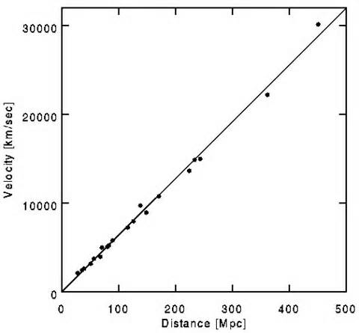s
Galaxy | Distance (Mpc) | Velocity (km/s) | H_{o}
1
2
3
4
5

Q 18. Calculate your average value for the Hubble Constant.
Q 19. What are the units of the Hubble Constant?

Q 20. How does your value compare to the value astronomers measure today for the Hubble constant?

Q 21. Can you accurately measure the Hubble Constant from 1 galaxy? What about 5 galaxies?

Now that you’ve measured the Hubble Constant,
you can calculate the age of the Universe!
1. You will first need to convert the distances you measured above for Mpc (Mega-parsecs) to kilometers.
1 Mpc = 3.18 x 10¹⁹km Record the new values in the table below.
2. Measure the Hubble Constant in units of (1/seconds) by dividing the velocity by the distance. Record
3. Measure the age of the Universe by taking the inverse of the Hubble Constant (1/H_{o}). Record

Galaxy | Distance (km) | Velocity (km/s) | H_{o} (1/s) | 1/H_{o}
1
2
3
4
5

Q 22. What is the average value you measure for the age of the Universe?
(Hint: 1 year = 3.16 x 10⁷ seconds)
Q 23. How does this age compare to the value astronomers measure today?
In Conclusion
4. From each of the observations you have made and/or calculated in this activity, inferences can be drawn. Write yours in the spaces below.

Observation | Inference
Almost all galaxies are redshifted.

The most distant galaxies exhibit the greatest redshift.

The ratio of recessional velocity to distance is between 50 and 100 km/s per kilo parsec and is called the Hubble Constant.

The Cosmic Background Explorer (COBE) found that the temperature of intergalactic space was not zero.

